­­­

[SAPSMHC-15765](https://jira.telekom.de/browse/SAPSMHC-15765) - Testcase system copy DB2

# Installation of 2 SID's same single host database over COSMOS Portal:





## Enable Database Backup on FI1



# Creation of copy relation in COSMOS Portal



# Creation of daily backup schedule for Source system > Reason is to produce snapshots which are only available on secondary storage in minimum after 6 days





fcishfi10201:fi1adm 27> cat xbrbackFI1.log

getijcab.dum 2023-08-01 07.02.57 2023-08-01 07.05.42 0

getijiia.anf 2023-08-01 07.30.40 2023-08-01 07.32.20 0

# Making changes to database

**fcishfi10201:db2fi1 4> db2 -stvf increment.sql -z increment.out**

CREATE DATABASE PARTITION GROUP "SAP_INCREMENT" ON DBPARTITIONNUMS (0)

DB20000I The SQL command completed successfully.

CREATE LARGE TABLESPACE "INCREMENTAL CHECKS" IN DATABASE PARTITION GROUP SAP_INCREMENT PAGESIZE 16384 MANAGED BY AUTOMATIC STORAGE USING STOGROUP "IBMSTOGROUP" AUTORESIZE YES INITIALSIZE 32 M MAXSIZE NONE EXTENTSIZE 2 PREFETCHSIZE AUTOMATIC BUFFERPOOL "IBMDEFAULTBP" DATA TAG INHERIT OVERHEAD INHERIT TRANSFERRATE INHERIT DROPPED TABLE RECOVERY OFF

DB20000I The SQL command completed successfully.

CREATE LARGE TABLESPACE "EXTRA_INCREMENT" IN DATABASE PARTITION GROUP SAP_INCREMENT PAGESIZE 16384 MANAGED BY AUTOMATIC STORAGE USING STOGROUP "IBMSTOGROUP" AUTORESIZE YES INITIALSIZE 32 M MAXSIZE NONE EXTENTSIZE 2 PREFETCHSIZE AUTOMATIC BUFFERPOOL "IBMDEFAULTBP" DATA TAG INHERIT OVERHEAD INHERIT TRANSFERRATE INHERIT DROPPED TABLE RECOVERY OFF

DB20000I The SQL command completed successfully.

CREATE SCHEMA "INCREMENTAL" AUTHORIZATION "SAPAZ9 "

DB20000I The SQL command completed successfully.

CREATE TABLE "INCREMENTAL "."INCREMENT" ( "VERSION" VARCHAR(216 OCTETS) NOT NULL WITH DEFAULT ' ' ) COMPRESS YES ADAPTIVE IN "INCREMENTAL CHECKS" INDEX IN "INCREMENTAL CHECKS" ORGANIZE BY ROW

DB20000I The SQL command completed successfully.

SET SYSIBM.NLS_STRING_UNITS = 'SYSTEM'

DB20000I The SQL command completed successfully.

CREATE UNIQUE INDEX "INCREMENTAL "."INCREMENT~0" ON "INCREMENTAL "."INCREMENT" ("VERSION" ASC) PCTFREE 0 COMPRESS YES INCLUDE NULL KEYS ALLOW REVERSE SCANS

DB20000I The SQL command completed successfully.

**fcishfi10201:db2fi1 5> touch /db2/FI1/sapdata1/pmu.test**

**fcishfi10201:db2fi1 6> ls -l /db2/FI1/sapdata1/**

total 4

drwxr-xr-x 3 db2fi1 dbfi1adm 4096 Jan 11 2023 db2fi1

-rw-r--r-- 1 db2fi1 dbfi1adm 0 Aug 1 07:45 pmu.test

**After doing changes archive logs on source (this is just to figure out if changes are being restored as part of backup not required in live env):**

db2 connect to fi1

db2 archive log for db fi1

db2 archive log for db fi1

db2 archive log for db fi1

db2 archive log for db fi1

# Take Backup after doing changes to database



**fcishfi10201:fi1adm 32> cat xbrbackFI1.log**

getijcab.dum 2023-08-01 07.02.57 2023-08-01 07.05.42 0

getijiia.anf 2023-08-01 07.30.40 2023-08-01 07.32.20 0

getijvis.anf 2023-08-01 07.56.27 2023-08-01 07.58.06 0

# Test SAP Cross Restore: With snapshot on primary storage based on "Source backup"

## Execute Dry Run first

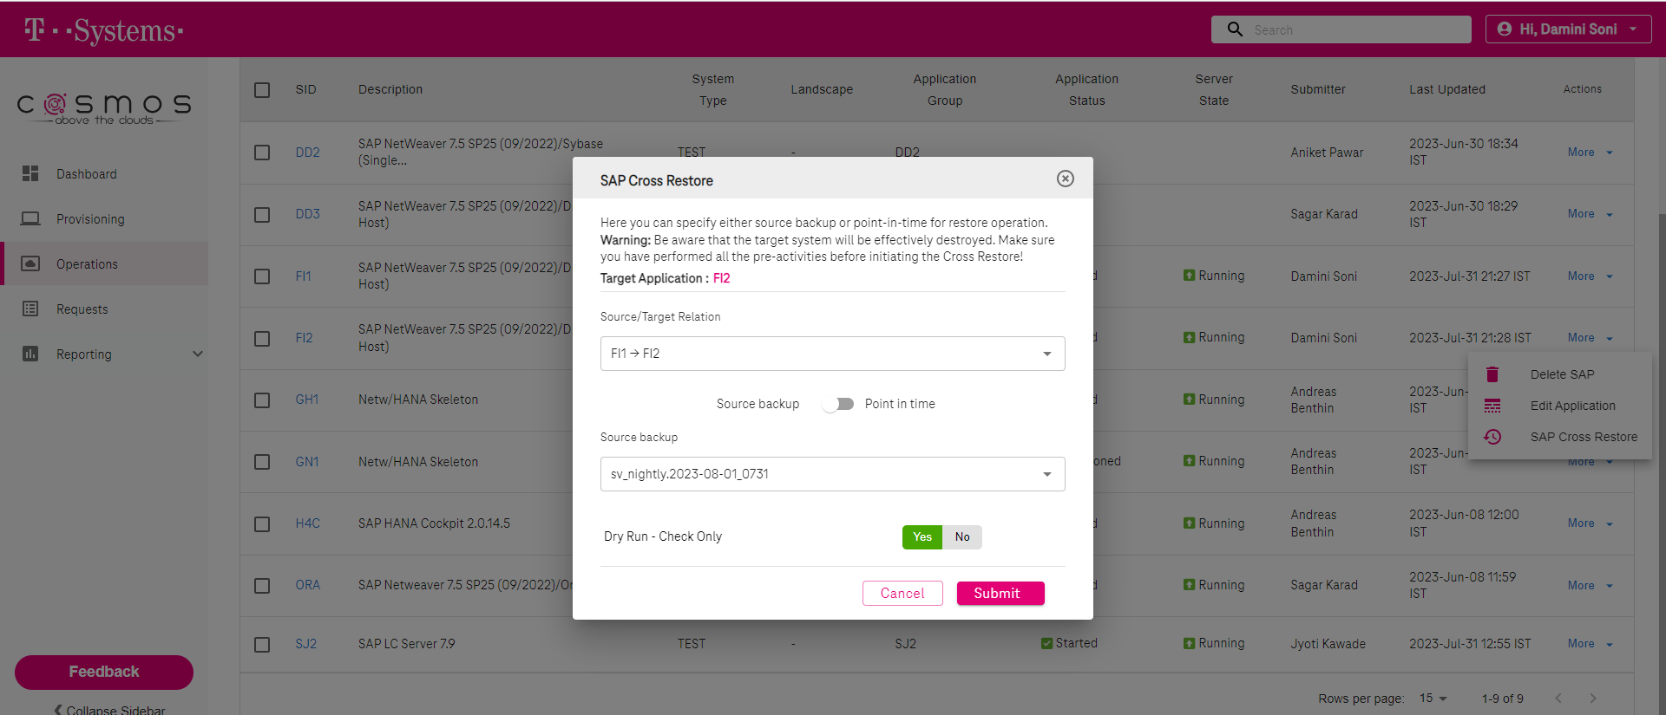



## Productive run:

**Before doing cross restore on target machine take backup of ddl and database privileges**

db2look -d FI2 -z SAPS25 -u SAPFI2 -xd -o db2look_sapfi2.sql

db2look -d FI2 -e -xd -o db2look_fi2.sql

**fcishfi20001:fi2adm 15> stopsap R3**

Checking db6 Database

Database is running

-------------------------------------------

stopping the SAP instance D00

Shutdown-Log is written to /usr/sap/FI2/home/stopsap_D00.log

-------------------------------------------

/usr/sap/FI2/D00/exe/sapcontrol -prot NI_HTTP -nr 00 -function Stop

Instance on host fcishfi20001 stopped

Waiting for cleanup of resources

................................

stopping the SAP instance ASCS01

Shutdown-Log is written to /usr/sap/FI2/home/stopsap_ASCS01.log

-------------------------------------------

/usr/sap/FI2/ASCS01/exe/sapcontrol -prot NI_HTTP -nr 01 -function Stop

Instance on host fcishfi20001 stopped

Waiting for cleanup of resources

.

fcishfi20001:fi2adm 16> logout

**fcishfi20001:~/.crossRestore # su - db2fi2**

**fcishfi20001:db2fi2 12> db2 list active databases**

SQL1611W No data was returned by Database System Monitor.

**fcishfi20001:db2fi2 12> db2stop**

08/01/2023 08:41:29 0 0 SQL1064N DB2STOP processing was successful.

SQL1064N DB2STOP processing was successful.

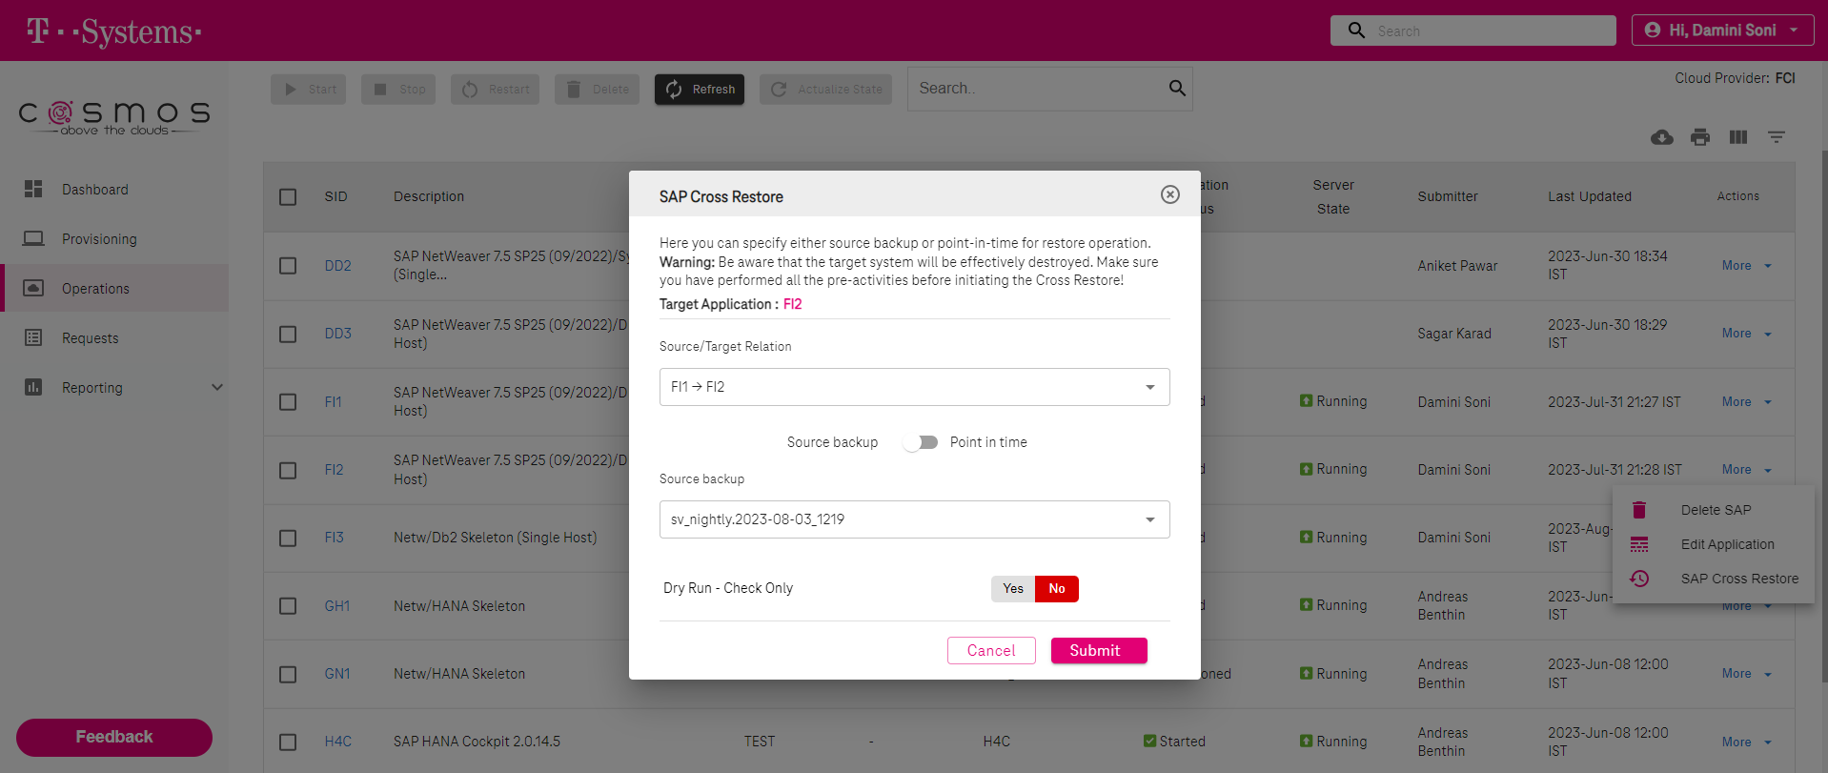



**fcishfi20001:db2fi2 54> ls -l /db2/FI2/archivepool/system_copy_180485/db2fi1/FI1/NODE0000/LOGSTREAM0000/C0000001/**

total 1288

-rw-r--r-- 1 32002 sapsys 1273856 Aug 3 12:19 S0000087.LOG

-rw-r--r-- 1 32002 sapsys 12288 Aug 3 12:19 S0000088.LOG

-rw-r--r-- 1 32002 sapsys 12288 Aug 3 12:20 S0000089.LOG

-rw-r--r-- 1 32002 sapsys 12288 Aug 3 12:20 S0000090.LOG

**fcishfi20001:db2fi2 56> db2start**

08/03/2023 16:39:20 0 0 SQL1063N DB2START processing was successful.

SQL1063N DB2START processing was successful.

**fcishfi20001:db2fi2 57> db2pd -**

Database Member 0 -- Active -- Up 0 days 00:00:16 -- Date 2023-08-03-16.39.35.576670

fcishfi20001:db2fi2 58> db2 list db directory

System Database Directory

Number of entries in the directory = 1

Database 1 entry:

Database alias = FI2

Database name = FI2

Local database directory = /db2/FI2

Database release level = 15.00

Comment = SAP database S25

Directory entry type = Indirect

Catalog database partition number = 0

Alternate server hostname =

Alternate server port number =

**fcishfi20001:db2fi2 61> pwd**

/home/db2fi2

**fcishfi20001:db2fi2 62> ls -ltr**

total 8

drwxr-xr-x 2 db2fi2 dbfi2adm 24 Jul 6 2021 public_html

drwxr-xr-x 2 db2fi2 dbfi2adm 6 Mar 15 2022 bin

drwxrwsr-t 24 db2fi2 dbfi2adm 4096 Jul 31 18:47 sqllib

-rw-r--r-- 1 db2fi2 dbfi2adm 501 Aug 1 08:36 relocate_fi1_fi2

**fcishfi20001:db2fi2 55> cat relocate_fi1_fi2**

DB_NAME=FI1,FI2

DB_PATH=/db2/FI1,/db2/FI2

INSTANCE=db2fi1,db2fi2

NODENUM=0

LOG_DIR=/db2/FI1/log_dir,/db2/FI2/log_dir

STORAGE_PATH=/db2/FI1/sapdata1,/db2/FI2/sapdata1

STORAGE_PATH=/db2/FI1/sapdata2,/db2/FI2/sapdata2

STORAGE_PATH=/db2/FI1/sapdata3,/db2/FI2/sapdata3

STORAGE_PATH=/db2/FI1/sapdata4,/db2/FI2/sapdata4

STORAGE_PATH=/db2/FI1/saptmp1,/db2/FI2/saptmp1

STORAGE_PATH=/db2/FI1/saptmp2,/db2/FI2/saptmp2

STORAGE_PATH=/db2/FI1/saptmp3,/db2/FI2/saptmp3

STORAGE_PATH=/db2/FI1/saptmp4,/db2/FI2/saptmp4

**fcishfi20001:db2fi2 63> db2 connect**

SQL1328N An implicit connection attempt failed. The database alias name or

database name "FI2" was not found in the local database directory.

SQLSTATE=42705

**fcishfi20001:db2fi2 64> db2inidb FI2 as standby relocate using relocate_fi1_fi2**

Relocating database...

Files and control structures were changed successfully.

Database was catalogued successfully.

DBT1000I The tool completed successfully.

Database relocation was successful.

DBT1000I The tool completed successfully.

**fcishfi20001:db2fi2 65> db2 update db cfg for FI2 using LOGARCHMETH1 DISK:/db2/FI2/log_archive/**

DB20000I The UPDATE DATABASE CONFIGURATION command completed successfully.

**fcishfi20001:db2fi2 66> rm -rf /db2/FI2/log_dir/NODE0000/LOGSTREAM0000/\***

rm: No match.

**fcishfi20001:db2fi2 67> ls -l /db2/FI2/log_dir/NODE0000/LOGSTREAM0000/**

total 0

**fcishfi20001:db2fi2 68> db2 update dbm cfg using INSTANCE_MEMORY 30**

DB20000I The UPDATE DATABASE MANAGER CONFIGURATION command completed

successfully.

**fcishfi20001:db2fi2 69> db2 update db cfg for FI2 using LOGPRIMARY 60**

DB20000I The UPDATE DATABASE CONFIGURATION command completed successfully.

**fcishfi20001:db2fi2 70> rm -rf /db2/FI2/log_archive/db2fi2/FI2/NODE0000/LOGSTREAM0000/\***

**fcishfi20001:db2fi2 71> db2stop; db2start**

08/03/2023 16:43:25 0 0 SQL1064N DB2STOP processing was successful.

SQL1064N DB2STOP processing was successful.

08/03/2023 16:43:26 0 0 SQL1063N DB2START processing was successful.

SQL1063N DB2START processing was successful.

**fcishfi20001:db2fi2 72> db2 rollforward db FI2 query status**

Rollforward Status

Input database alias = FI2

Number of members have returned status = 1

Member ID = 0

Rollforward status = DB pending

Next log file to be read = S0000088.LOG

Log files processed = S0000008.LOG - S0000069.LOG

Last committed transaction = 2023-08-03-10.19.34.000000 UTC

**fcishfi20001:db2fi2 73> db2 rollforward db FI2 to end of logs and complete overflow log path "(/db2/FI2/archivepool/system_copy_180485/db2fi1/FI1/NODE0000/LOGSTREAM0000/C0000001/)"**

Rollforward Status

Input database alias = FI2

Number of members have returned status = 1

Member ID = 0

Rollforward status = not pending

Next log file to be read =

Log files processed = S0000088.LOG - S0000089.LOG

Last committed transaction = 2023-08-03-10.20.21.000000 UTC

DB20000I The ROLLFORWARD command completed successfully.

**fcishfi20001:db2fi2 74> db2 connect**

Database Connection Information

Database server = DB2/LINUXX8664 11.5.8.0

SQL authorization ID = DB2FI2

Local database alias = FI2

# Recovered Changes-

**fcishfi20001:db2fi2 76> db2pd -db fi2 -tablespace | grep -i increment**

0x00007F19E68C9900 1 DMS Large 16384 2 Yes 2 1 1 Def 1 0 511 Yes INCREMENTAL CHECKS

0x00007F19E68D6CC0 2 DMS Large 16384 2 Yes 2 1 1 Def 1 0 511 Yes EXTRA_INCREMENT

**fcishfi20001:db2fi2 77> db2 list tables for all | grep -i increment**

INCREMENT INCREMENTAL T 2023-08-01-07.43.13.495105

**fcishfi20001:db2fi2 78> db2 load query table INCREMENTAL.INCREMENT**

Tablestate:

Normal

**fcishfi20001:fi2adm 57> ls -ltr /db2/FI2/sapdata1/**

total 4

-rwxr-xr-x 1 db2fi2 dbfi2adm 0 Aug 1 07:45 pmu.test

drwxr-xr-x 3 db2fi2 dbfi2adm 4096 Aug 3 11:46 db2fi2

fcishfi20001:fi2adm 58>

# Applications Not able to connect due to permissions according to source database which has been changed manually and then applications were able to connect to database

**fcishfi20001:db2fi2 53> db2 activate db fi2**

DB20000I The ACTIVATE DATABASE command completed successfully.

**fcishfi20001:db2fi2 54> db2 list active databases**

Active Databases

Database name = FI2

Applications connected currently = 0

Database path = /db2/FI2/db2fi2/NODE0000/SQL00001/MEMBER0000/

fcishfi20001:db2fi2 55> logout

fcishfi20001:~ # su - fi2adm

**fcishfi20001:fi2adm 52> R3trans -d**

This is R3trans version 6.26 (release 753 - 20.09.22 - 12:12:00 with rjh730).

unicode enabled version

2EETW000 I have some problems during TADIR access.

1AETW000 ERROR: first character of SAP-Release is not a digit, but '

2EETW000 Please contact the SAP support.

exiting ...

R3trans finished (0016).

**fcishfi20001:fi2adm 54> cat trans.log | tail -100**

4 ETW000 [ dev trc,00000] NTAB: db_ntab(): init_ntab failed, returning 4

4 ETW000 [ dev trc,00000] *** ERROR in prepareStatement[/bas/753_REL/src/dbs/db6/dbdb6.c, 15098] CON = 0 CACHEID = 18 (BEGIN)

4 ETW000 [ dev trc,00000] &+ DbSlBegReadDB6( SQLExtendedPrepare ): [IBM][CLI Driver][DB2/LINUXX8664] SQL0204N "SAPS25.XXXXT" is an undefined n

4 ETW000 [ dev trc,00000] &+ ame. SQLSTATE=42704

4 ETW000 [ dev trc,00000] &+

4 ETW000 [ dev trc,00000] &+ SELECT * FROM "XXXXT" WHERE TABNAME = 'SVERS' WITH UR

4 ETW000 [ dev trc,00000] &+ cursor type=NO_HOLD, isolation=UR, cc_release=YES, optlevel=5, degree=-1, op_type=18, read_only=1

4 ETW000 [ dev trc,00000] &+

4 ETW000 [ dev trc,00000] &+

4 ETW000 [ dev trc,00000] *** ERROR in prepareStatement[/bas/753_REL/src/dbs/db6/dbdb6.c, 15098] (END)

4 ETW000 [dbntab.c ,00000] *** ERROR => NTAB: get_ntab_db_structure(): ddntt_column_check() returned dbsl error 103

4 ETW000 [ dev trc,00000] NTAB: db_ntab(): init_ntab failed, returning 4

4 ETW000 [ dev trc,00000] *** ERROR in prepareStatement[/bas/753_REL/src/dbs/db6/dbdb6.c, 15098] CON = 0 CACHEID = 19 (BEGIN)

4 ETW000 [ dev trc,00000] &+ DbSlBegReadDB6( SQLExtendedPrepare ): [IBM][CLI Driver][DB2/LINUXX8664] SQL0204N "SAPS25.XXXXT" is an undefined n

4 ETW000 [ dev trc,00000] &+ ame. SQLSTATE=42704

4 ETW000 [ dev trc,00000] &+

4 ETW000 [ dev trc,00000] &+ SELECT * FROM "XXXXT" WHERE TABNAME = 'SVERS' WITH UR

4 ETW000 [ dev trc,00000] &+ cursor type=NO_HOLD, isolation=UR, cc_release=YES, optlevel=5, degree=-1, op_type=18, read_only=1

4 ETW000 [ dev trc,00000] &+

4 ETW000 [ dev trc,00000] &+

4 ETW000 [ dev trc,00000] *** ERROR in prepareStatement[/bas/753_REL/src/dbs/db6/dbdb6.c, 15098] (END)

4 ETW000 [dbntab.c ,00000] *** ERROR => NTAB: get_ntab_db_structure(): ddntt_column_check() returned dbsl error 103

4 ETW000 [ dev trc,00000] NTAB: db_ntab(): init_ntab failed, returning 4

4 ETW000 [ dev trc,00000] *** ERROR in prepareStatement[/bas/753_REL/src/dbs/db6/dbdb6.c, 15098] CON = 0 CACHEID = 20 (BEGIN)

4 ETW000 [ dev trc,00000] &+ DbSlBegReadDB6( SQLExtendedPrepare ): [IBM][CLI Driver][DB2/LINUXX8664] SQL0204N "SAPS25.XXXXT" is an undefined n

4 ETW000 [ dev trc,00000] &+ ame. SQLSTATE=42704

4 ETW000 [ dev trc,00000] &+

4 ETW000 [ dev trc,00000] &+ SELECT * FROM "XXXXT" WHERE TABNAME = 'SVERS' WITH UR

4 ETW000 [ dev trc,00000] &+ cursor type=NO_HOLD, isolation=UR, cc_release=YES, optlevel=5, degree=-1, op_type=18, read_only=1

4 ETW000 [ dev trc,00000] &+

4 ETW000 [ dev trc,00000] &+

4 ETW000 [ dev trc,00000] *** ERROR in prepareStatement[/bas/753_REL/src/dbs/db6/dbdb6.c, 15098] (END)

4 ETW000 [dbntab.c ,00000] *** ERROR => NTAB: get_ntab_db_structure(): ddntt_column_check() returned dbsl error 103

4 ETW000 [ dev trc,00000] NTAB: db_ntab(): init_ntab failed, returning 4

4 ETW000 [ dev trc,00000] *** ERROR in prepareStatement[/bas/753_REL/src/dbs/db6/dbdb6.c, 15098] CON = 0 CACHEID = 21 (BEGIN)

4 ETW000 [ dev trc,00000] &+ DbSlBegReadDB6( SQLExtendedPrepare ): [IBM][CLI Driver][DB2/LINUXX8664] SQL0204N "SAPS25.XXXXT" is an undefined n

4 ETW000 [ dev trc,00000] &+ ame. SQLSTATE=42704

4 ETW000 [ dev trc,00000] &+

4 ETW000 [ dev trc,00000] &+ SELECT * FROM "XXXXT" WHERE TABNAME = 'SVERS' WITH UR

4 ETW000 [ dev trc,00000] &+ cursor type=NO_HOLD, isolation=UR, cc_release=YES, optlevel=5, degree=-1, op_type=18, read_only=1

4 ETW000 [ dev trc,00000] &+

4 ETW000 [ dev trc,00000] &+

4 ETW000 [ dev trc,00000] *** ERROR in prepareStatement[/bas/753_REL/src/dbs/db6/dbdb6.c, 15098] (END)

4 ETW000 [dbntab.c ,00000] *** ERROR => NTAB: get_ntab_db_structure(): ddntt_column_check() returned dbsl error 103

4 ETW000 [ dev trc,00000] NTAB: db_ntab(): init_ntab failed, returning 4

4 ETW000 [ dev trc,00000] *** ERROR in prepareStatement[/bas/753_REL/src/dbs/db6/dbdb6.c, 15098] CON = 0 CACHEID = 22 (BEGIN)

4 ETW000 [ dev trc,00000] &+ DbSlBegReadDB6( SQLExtendedPrepare ): [IBM][CLI Driver][DB2/LINUXX8664] SQL0204N "SAPS25.XXXXT" is an undefined n

4 ETW000 [ dev trc,00000] &+ ame. SQLSTATE=42704

4 ETW000 [ dev trc,00000] &+

4 ETW000 [ dev trc,00000] &+ SELECT * FROM "XXXXT" WHERE TABNAME = 'SVERS' WITH UR

4 ETW000 [ dev trc,00000] &+ cursor type=NO_HOLD, isolation=UR, cc_release=YES, optlevel=5, degree=-1, op_type=18, read_only=1

4 ETW000 [ dev trc,00000] &+

4 ETW000 [ dev trc,00000] &+

4 ETW000 [ dev trc,00000] *** ERROR in prepareStatement[/bas/753_REL/src/dbs/db6/dbdb6.c, 15098] (END)

4 ETW000 [dbntab.c ,00000] *** ERROR => NTAB: get_ntab_db_structure(): ddntt_column_check() returned dbsl error 103

4 ETW000 [ dev trc,00000] NTAB: db_ntab(): init_ntab failed, returning 4

4 ETW000 [ dev trc,00000] *** ERROR in prepareStatement[/bas/753_REL/src/dbs/db6/dbdb6.c, 15098] CON = 0 CACHEID = 23 (BEGIN)

4 ETW000 [ dev trc,00000] &+ DbSlBegReadDB6( SQLExtendedPrepare ): [IBM][CLI Driver][DB2/LINUXX8664] SQL0204N "SAPS25.XXXXT" is an undefined n

4 ETW000 [ dev trc,00000] &+ ame. SQLSTATE=42704

4 ETW000 [ dev trc,00000] &+

4 ETW000 [ dev trc,00000] &+ SELECT * FROM "XXXXT" WHERE TABNAME = 'SVERS' WITH UR

4 ETW000 [ dev trc,00000] &+ cursor type=NO_HOLD, isolation=UR, cc_release=YES, optlevel=5, degree=-1, op_type=18, read_only=1

4 ETW000 [ dev trc,00000] &+

4 ETW000 [ dev trc,00000] &+

4 ETW000 [ dev trc,00000] *** ERROR in prepareStatement[/bas/753_REL/src/dbs/db6/dbdb6.c, 15098] (END)

4 ETW000 [dbntab.c ,00000] *** ERROR => NTAB: get_ntab_db_structure(): ddntt_column_check() returned dbsl error 103

4 ETW000 [ dev trc,00000] NTAB: db_ntab(): init_ntab failed, returning 4

4 ETW000 [ dev trc,00000] *** ERROR in prepareStatement[/bas/753_REL/src/dbs/db6/dbdb6.c, 15098] CON = 0 CACHEID = 24 (BEGIN)

4 ETW000 [ dev trc,00000] &+ DbSlBegReadDB6( SQLExtendedPrepare ): [IBM][CLI Driver][DB2/LINUXX8664] SQL0204N "SAPS25.XXXXT" is an undefined n

4 ETW000 [ dev trc,00000] &+ ame. SQLSTATE=42704

4 ETW000 [ dev trc,00000] &+

4 ETW000 [ dev trc,00000] &+ SELECT * FROM "XXXXT" WHERE TABNAME = 'SVERS' WITH UR

4 ETW000 [ dev trc,00000] &+ cursor type=NO_HOLD, isolation=UR, cc_release=YES, optlevel=5, degree=-1, op_type=18, read_only=1

4 ETW000 [ dev trc,00000] &+

4 ETW000 [ dev trc,00000] &+

4 ETW000 [ dev trc,00000] *** ERROR in prepareStatement[/bas/753_REL/src/dbs/db6/dbdb6.c, 15098] (END)

4 ETW000 [dbntab.c ,00000] *** ERROR => NTAB: get_ntab_db_structure(): ddntt_column_check() returned dbsl error 103

4 ETW000 [ dev trc,00000] NTAB: db_ntab(): init_ntab failed, returning 4

4 ETW000 [ dev trc,00000] *** ERROR in prepareStatement[/bas/753_REL/src/dbs/db6/dbdb6.c, 15098] CON = 0 CACHEID = 25 (BEGIN)

4 ETW000 [ dev trc,00000] &+ DbSlBegReadDB6( SQLExtendedPrepare ): [IBM][CLI Driver][DB2/LINUXX8664] SQL0204N "SAPS25.XXXXT" is an undefined n

4 ETW000 [ dev trc,00000] &+ ame. SQLSTATE=42704

4 ETW000 [ dev trc,00000] &+

4 ETW000 [ dev trc,00000] &+ SELECT * FROM "XXXXT" WHERE TABNAME = 'SVERS' WITH UR

4 ETW000 [ dev trc,00000] &+ cursor type=NO_HOLD, isolation=UR, cc_release=YES, optlevel=5, degree=-1, op_type=18, read_only=1

4 ETW000 [ dev trc,00000] &+

4 ETW000 [ dev trc,00000] &+

4 ETW000 [ dev trc,00000] *** ERROR in prepareStatement[/bas/753_REL/src/dbs/db6/dbdb6.c, 15098] (END)

4 ETW000 [dbntab.c ,00000] *** ERROR => NTAB: get_ntab_db_structure(): ddntt_column_check() returned dbsl error 103

4 ETW000 [ dev trc,00000] NTAB: db_ntab(): init_ntab failed, returning 4

4 ETW000

2EETW000 I have some problems during TADIR access.

4 ETW000 Connected to DBMS = DB6 --- DB2DBDFT = 'FI2' --- SYSTEM = '???'.

3WETW000 The HEAD entry in TADIR is missing.

1AETW000 ERROR: first character of SAP-Release is not a digit, but '

2EETW000 Please contact the SAP support.

4 ETW690 ROLLBACK "0" "0"

4 ETW000 End of Transport (0016).

4 ETW000 date&time: 03.08.2023 - 17:22:39

4 ETW000 1 warning occured.

**fcishfi20001:db2fi2 53> db2 grant DBADM on database to user fi2adm**

DB20000I The SQL command completed successfully.

**fcishfi20001:db2fi2 54> db2 grant DBADM on database to user sapfi2**

DB20000I The SQL command completed successfully.

fcishfi20001:db2fi2 55>

**fcishfi20001:db2fi2 55> db2 GRANT DBADM,CREATETAB,BINDADD,CONNECT,CREATE_NOT_FENCED_ROUTINE,IMPLICIT_SCHEMA,LOAD,CREATE_EXTERNAL_ROUTINE,QUIESCE_CONNECT ON DATABASE** **to user fi2adm**

DB20000I The SQL command completed successfully.

**fcishfi20001:db2fi2 56> db2 GRANT SECADM ON DATABASE to user sapfi2**

DB20000I The SQL command completed successfully.

**fcishfi20001:db2fi2 57> db2 GRANT SECADM ON DATABASE to user fi2adm**

DB20000I The SQL command completed successfully.

**fcishfi20001:db2fi2 58> env | grep -i schema**

dbs_db6_schema=saps25

**fcishfi20001:db2fi2 62> db2 "select 'transfer ownership of view ' || varchar(viewschema,6) || '.' || viewname || ' to user sapfi2 preserve privileges;' from syscat.views where OWNER!='sapfi2' and viewschema='SAPS25' and viewname not like '%/%'" > script_FI2.sql**

**fcishfi20001:db2fi2 65> db2 -stvf script_FI2.sql -z script_FI2.out**

..

transfer ownership of view SAPS25.V_EXT_ACT to user sapfi2 preserve privileges

DB20000I The SQL command completed successfully.

transfer ownership of view SAPS25.SEPM_SDDL_V_GII to user sapfi2 preserve privileges

DB20000I The SQL command completed successfully.

DB21007E End of file reached while reading the command.

fcishfi20001:db2fi2 66>

**fcishfi20001:fi2adm 53> R3trans -d -v**

This is R3trans version 6.26 (release 753 - 20.09.22 - 12:12:00 with rjh730).

unicode enabled version

R3trans finished (0000).

**fcishfi20001:fi2adm 54> startsap**

Checking db6 Database

Database is running

-------------------------------------------

Starting Startup Agent sapstartsrv

OK

Instance Service on host fcishfi20001 started

-------------------------------------------

starting SAP Instance ASCS01

Startup-Log is written to /usr/sap/FI2/home/startsap_ASCS01.log

-------------------------------------------

/usr/sap/FI2/ASCS01/exe/sapcontrol -prot NI_HTTP -nr 01 -function Start

Instance on host fcishfi20001 started

Starting Startup Agent sapstartsrv

OK

Instance Service on host fcishfi20001 started

-------------------------------------------

starting SAP Instance D00

Startup-Log is written to /usr/sap/FI2/home/startsap_D00.log

-------------------------------------------

/usr/sap/FI2/D00/exe/sapcontrol -prot NI_HTTP -nr 00 -function Start

Instance on host fcishfi20001 started

fcishfi20001:fi2adm 55>

**fcishfi20001:fi2adm 55> db2 list active databases**

Active Databases

Database name = FI2

**Applications connected currently = 20**

Database path = /db2/FI2/db2fi2/NODE0000/SQL00001/MEMBER0000/

fcishfi20001:fi2adm 56>

# POINT IN TIME (Primary Site)

## Execute Dry Run:

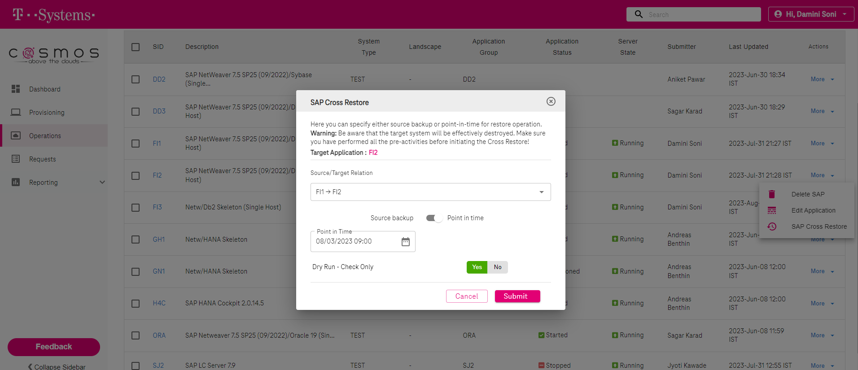





## Productive Dry Run:

**fcishfi20001:fi2adm 51> stopsap**

Checking db6 Database

Database is running

-------------------------------------------

stopping the SAP instance D00

Shutdown-Log is written to /usr/sap/FI2/home/stopsap_D00.log

-------------------------------------------

/usr/sap/FI2/D00/exe/sapcontrol -prot NI_HTTP -nr 00 -function Stop

Instance on host fcishfi20001 stopped

Waiting for cleanup of resources

...........

stopping the SAP instance ASCS01

Shutdown-Log is written to /usr/sap/FI2/home/stopsap_ASCS01.log

-------------------------------------------

/usr/sap/FI2/ASCS01/exe/sapcontrol -prot NI_HTTP -nr 01 -function Stop

Instance on host fcishfi20001 stopped

Waiting for cleanup of resources

.

Database is running

Continue with stop procedure

DB20000I The DEACTIVATE DATABASE command completed successfully.

08/03/2023 18:46:01 0 0 SQL1064N DB2STOP processing was successful.

SQL1064N DB2STOP processing was successful.

Database sucessfully stopped

Checking db6 Database

Database is not available via R3trans

-------------------------------------------

fcishfi20001:fi2adm 52>

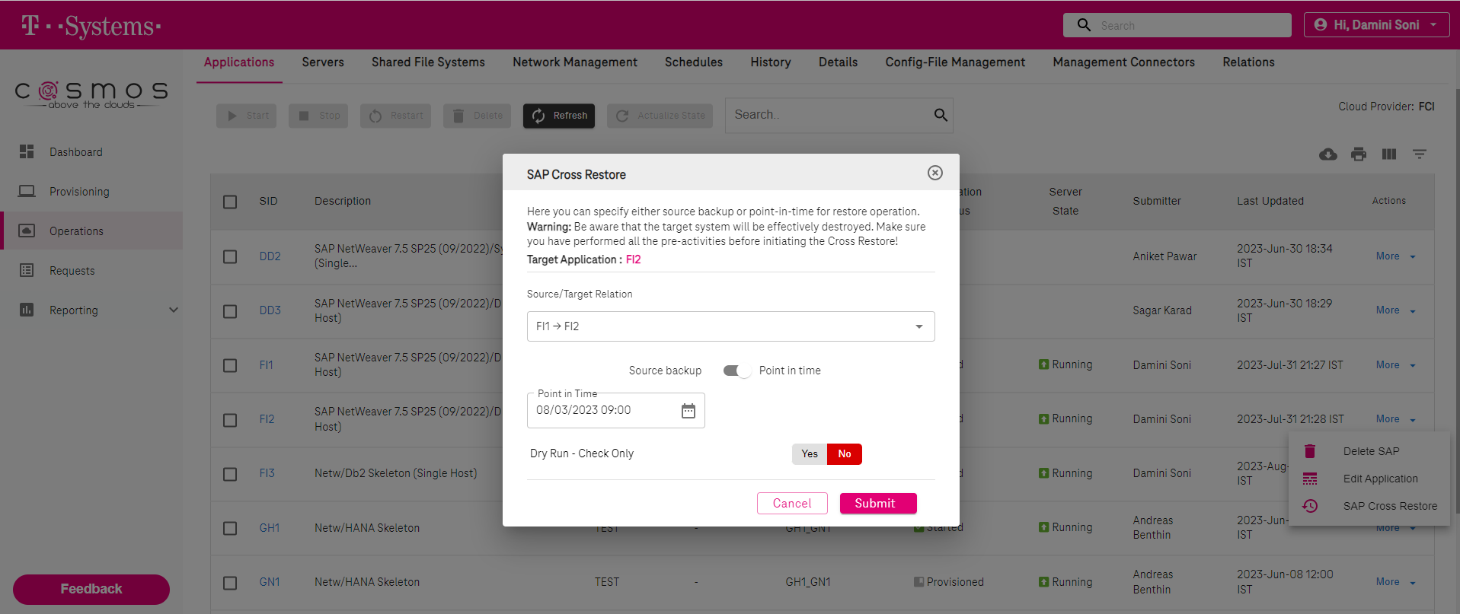



**fcishfi20001:fi2adm 52> db2pd -**

Unable to attach to database manager on member 0.

Please ensure the following are true:

- db2start has been run for the member.

- db2pd is being run on the same physical machine as the member.

- DB2NODE environment variable setting is correct for the member

or db2pd -mem setting is correct for the member.

Another possibility of this failure is the Virtual Address Space Randomization is currently enabled on this system.

**fcishfi20001:db2fi2 57> ls -ltr /db2/FI2/archivepool/system_copy_180531/**

total 38228

-rw-r--r-- 1 32002 sapsys 59486 Aug 1 12:50 xbrbackstatFI1.log

-rw-r--r-- 1 32002 sapsys 1102 Aug 2 07:30 xbrbackFI1.log

-rw-r--r-- 1 32002 sapsys 2726 Aug 2 07:31 DBM.cfg

-rw-r--r-- 1 32002 sapsys 38830080 Aug 2 07:31 FI1_db2_home.tar.Z

-rw-r--r-- 1 32002 sapsys 67740 Aug 2 07:32 getjvrba.anf

drwxr-xr-x 3 32002 sapsys 4096 Aug 3 18:59 db2fi1

**fcishfi20001:db2fi2 60> ls -ltr /db2/FI2/archivepool/system_copy_180531/ db2fi1/FI1/NODE0000/LOGSTREAM0000/C0000000/**

total 156972

-rw-r--r-- 1 32002 sapsys 4980736 Aug 2 07:31 S0000034.LOG

-rw-r--r-- 1 32002 sapsys 12288 Aug 2 07:31 S0000035.LOG

-rw-r--r-- 1 32002 sapsys 12288 Aug 2 07:31 S0000036.LOG

-rw-r--r-- 1 32002 sapsys 12288 Aug 2 07:32 S0000037.LOG

-rw-r--r-- 1 32002 sapsys 12742656 Aug 2 08:35 S0000038.LOG

-rw-r--r-- 1 32002 sapsys 5050368 Aug 2 09:35 S0000039.LOG

-rw-r--r-- 1 32002 sapsys 11698176 Aug 2 10:35 S0000040.LOG

-rw-r--r-- 1 32002 sapsys 5054464 Aug 2 11:35 S0000041.LOG

-rw-r--r-- 1 32002 sapsys 12107776 Aug 2 12:35 S0000042.LOG

-rw-r--r-- 1 32002 sapsys 5046272 Aug 2 13:35 S0000043.LOG

-rw-r--r-- 1 32002 sapsys 11292672 Aug 2 14:35 S0000044.LOG

-rw-r--r-- 1 32002 sapsys 5058560 Aug 2 15:35 S0000045.LOG

-rw-r--r-- 1 32002 sapsys 11796480 Aug 2 16:35 S0000046.LOG

-rw-r--r-- 1 32002 sapsys 5058560 Aug 2 17:35 S0000047.LOG

-rw-r--r-- 1 32002 sapsys 12267520 Aug 2 18:35 S0000048.LOG

-rw-r--r-- 1 32002 sapsys 5054464 Aug 2 19:35 S0000049.LOG

-rw-r--r-- 1 32002 sapsys 135168 Aug 2 20:35 S0000050.LOG

-rw-r--r-- 1 32002 sapsys 17661952 Aug 2 21:35 S0000051.LOG

-rw-r--r-- 1 32002 sapsys 135168 Aug 2 22:35 S0000052.LOG

-rw-r--r-- 1 32002 sapsys 17055744 Aug 2 23:35 S0000053.LOG

-rw-r--r-- 1 32002 sapsys 131072 Aug 3 00:35 S0000054.LOG

-rw-r--r-- 1 32002 sapsys 17539072 Aug 3 01:35 S0000055.LOG

-rw-r--r-- 1 32002 sapsys 135168 Aug 3 02:35 S0000056.LOG

**fcishfi20001:db2fi2 61> date**

Thu 03 Aug 2023 07:10:12 PM CEST

**fcishfi20001:db2fi2 63> db2start**

08/03/2023 19:18:38 0 0 SQL1063N DB2START processing was successful.

SQL1063N DB2START processing was successful.

**fcishfi20001:db2fi2 64> db2pd -**

Database Member 0 -- Active -- Up 0 days 00:00:07 -- Date 2023-08-03-19.18.44.454202

**fcishfi20001:db2fi2 67> db2 connect**

SQL1328N An implicit connection attempt failed. The database alias name or

database name "FI2" was not found in the local database directory.

SQLSTATE=42705

**fcishfi20001:db2fi2 68> pwd**

/home/db2fi2

**fcishfi20001:db2fi2 69> db2inidb FI2 as standby relocate using relocate_fi1_fi2**

Relocating database...

Files and control structures were changed successfully.

Database was catalogued successfully.

DBT1000I The tool completed successfully.

Database relocation was successful.

DBT1000I The tool completed successfully.

**fcishfi20001:db2fi2 70> db2 update db cfg for FI2 using LOGARCHMETH1 DISK:/db2/FI2/log_archive/**

DB20000I The UPDATE DATABASE CONFIGURATION command completed successfully.

**fcishfi20001:db2fi2 71> rm -rf /db2/FI2/log_dir/NODE0000/LOGSTREAM0000/\***

**fcishfi20001:db2fi2 73> db2 update dbm cfg using INSTANCE_MEMORY 30**

DB20000I The UPDATE DATABASE MANAGER CONFIGURATION command completed

successfully.

**fcishfi20001:db2fi2 74> db2 update db cfg for FI2 using LOGPRIMARY 60**

DB20000I The UPDATE DATABASE CONFIGURATION command completed successfully.

**fcishfi20001:db2fi2 75> rm -rf /db2/FI2/log_archive/db2fi2/FI2/NODE0000/LOGSTREAM0000/\***

**fcishfi20001:db2fi2 76> db2stop; db2start**

08/03/2023 19:21:08 0 0 SQL1064N DB2STOP processing was successful.

SQL1064N DB2STOP processing was successful.

08/03/2023 19:21:10 0 0 SQL1063N DB2START processing was successful.

SQL1063N DB2START processing was successful.

**fcishfi20001:db2fi2 77> db2 rollforward db FI2 query status**

Rollforward Status

Input database alias = FI2

Number of members have returned status = 1

Member ID = 0

Rollforward status = DB pending

Next log file to be read = S0000035.LOG

Log files processed = -

Last committed transaction = 2023-08-02-05.31.29.000000 UTC

**fcishfi20001:db2fi2 78> ls -l /db2/FI2/archivepool/system_copy_180531/db2fi1/FI1/NODE0000/LOGSTREAM0000/C0000000/**

total 156972

-rw-r--r-- 1 32002 sapsys 4980736 Aug 2 07:31 S0000034.LOG

-rw-r--r-- 1 32002 sapsys 12288 Aug 2 07:31 S0000035.LOG

-rw-r--r-- 1 32002 sapsys 12288 Aug 2 07:31 S0000036.LOG

-rw-r--r-- 1 32002 sapsys 12288 Aug 2 07:32 S0000037.LOG

-rw-r--r-- 1 32002 sapsys 12742656 Aug 2 08:35 S0000038.LOG

-rw-r--r-- 1 32002 sapsys 5050368 Aug 2 09:35 S0000039.LOG

-rw-r--r-- 1 32002 sapsys 11698176 Aug 2 10:35 S0000040.LOG

-rw-r--r-- 1 32002 sapsys 5054464 Aug 2 11:35 S0000041.LOG

-rw-r--r-- 1 32002 sapsys 12107776 Aug 2 12:35 S0000042.LOG

-rw-r--r-- 1 32002 sapsys 5046272 Aug 2 13:35 S0000043.LOG

-rw-r--r-- 1 32002 sapsys 11292672 Aug 2 14:35 S0000044.LOG

-rw-r--r-- 1 32002 sapsys 5058560 Aug 2 15:35 S0000045.LOG

-rw-r--r-- 1 32002 sapsys 11796480 Aug 2 16:35 S0000046.LOG

-rw-r--r-- 1 32002 sapsys 5058560 Aug 2 17:35 S0000047.LOG

-rw-r--r-- 1 32002 sapsys 12267520 Aug 2 18:35 S0000048.LOG

-rw-r--r-- 1 32002 sapsys 5054464 Aug 2 19:35 S0000049.LOG

-rw-r--r-- 1 32002 sapsys 135168 Aug 2 20:35 S0000050.LOG

-rw-r--r-- 1 32002 sapsys 17661952 Aug 2 21:35 S0000051.LOG

-rw-r--r-- 1 32002 sapsys 135168 Aug 2 22:35 S0000052.LOG

-rw-r--r-- 1 32002 sapsys 17055744 Aug 2 23:35 S0000053.LOG

-rw-r--r-- 1 32002 sapsys 131072 Aug 3 00:35 S0000054.LOG

-rw-r--r-- 1 32002 sapsys 17539072 Aug 3 01:35 S0000055.LOG

-rw-r--r-- 1 32002 sapsys 135168 Aug 3 02:35 S0000056.LOG

**fcishfi20001:db2fi2 84> db2 rollforward db fi2 to end of logs and complete overflow log path "(/db2/FI2/archivepool/system_copy_180531/db2fi1/FI1/NODE0000/LOGSTREAM0000/C0000000/)"**

Rollforward Status

Input database alias = fi2

Number of members have returned status = 1

Member ID = 0

Rollforward status = not pending

Next log file to be read =

Log files processed = S0000035.LOG - S0000055.LOG

Last committed transaction = 2023-08-03-00.34.28.000000 UTC

DB20000I The ROLLFORWARD command completed successfully.

fcishfi20001:db2fi2 85>

# Recovered Changes-

**fcishfi20001:db2fi2 88> db2pd -db fi2 -tablespace | grep -i increment**

0x00007F19E68C9900 1 DMS Large 16384 2 Yes 2 1 1 Def 1 0 511 Yes INCREMENTAL CHECKS

0x00007F19E68D6CC0 2 DMS Large 16384 2 Yes 2 1 1 Def 1 0 511 Yes EXTRA_INCREMENT

**fcishfi20001:db2fi2 89> db2 list tables for all | grep -i increment**

INCREMENT INCREMENTAL T 2023-08-01-07.43.13.495105

**fcishfi20001:db2fi2 90> db2 load query table INCREMENTAL.INCREMENT**

Tablestate:

Normal

**fcishfi20001:fi2adm 57> ls -ltr /db2/FI2/sapdata1/**

total 4

-rwxr-xr-x 1 db2fi2 dbfi2adm 0 Aug 1 07:45 pmu.test

drwxr-xr-x 3 db2fi2 dbfi2adm 4096 Aug 3 11:46 db2fi2

fcishfi20001:fi2adm 58>

**NOTE: CAN FOLLOW THE SAME PROCESS TO GET THE APPLICATIONS CONNECTED TO DATABASE AS DONE IN SOURCE BACKUP RESTORE**

# Secondary Site:

## Source Backup Restore

**fcishfi10201:fi1adm 57> sudo /usr/local/platform/bin/iaas.py --cfg ~/FI1 --mode application --action list_snapshot**

2023-10-11 09:51:05,408 - INFO - Iaas Tool Storage Provider Version (FciFaas): 1.2.2

2023-10-11 09:51:05,408 - INFO - List all snapshots

2023-10-11 09:51:06,251 - INFO - .. Snapshot: sv_nightly.2023-10-11_0942

2023-10-11 09:51:06,251 - INFO - .. Creation-date: 2023-10-11T09:42:12+02:00

2023-10-11 09:51:06,251 - INFO - .. Unix timestamp: 1697010132

2023-10-11 09:51:06,251 - INFO - .. Volume: fcivssc0083002_fi1db_data001

2023-10-11 09:51:06,251 - INFO - .. Job-ID: sv_nightly.2023-10-11_0942

2023-10-11 09:51:06,251 - INFO - .. Transfer: true

**fcishfi10201:fi1adm 58> sudo /usr/local/platform/bin/iaas.py --cfg ~/FI1 --mode application --action list_backup**

2023-10-11 09:51:11,357 - INFO - Iaas Tool Storage Provider Version (FciFaas): 1.2.2

2023-10-11 09:51:11,358 - INFO - List all backups

2023-10-11 09:51:12,457 - INFO - .. Snapshot: sv_nightly.2023-10-11_0942

2023-10-11 09:51:12,457 - INFO - .. Creation-date: 2023-10-11T09:42:12+02:00

2023-10-11 09:51:12,457 - INFO - .. Unix timestamp: 1697010132

2023-10-11 09:51:12,458 - INFO - .. Volume: fcivsbc0083002_fi1db_data001

2023-10-11 09:51:12,458 - INFO - .. Job-ID: sv_nightly.2023-10-11_0942

**2023-10-11 09:51:12,458 - INFO - .. Snapshot: sv_nightly.2023-10-10_1501**

2023-10-11 09:51:12,458 - INFO - .. Creation-date: 2023-10-10T15:01:36+02:00

2023-10-11 09:51:12,458 - INFO - .. Unix timestamp: 1696942896

2023-10-11 09:51:12,458 - INFO - .. Volume: fcivsbc0083002_fi1db_data001

2023-10-11 09:51:12,458 - INFO - .. Job-ID: sv_nightly.2023-10-10_1501

..

2023-10-11 09:51:12,468 - INFO - .. Snapshot: sv_nightly.2023-08-01_0731

2023-10-11 09:51:12,468 - INFO - .. Creation-date: 2023-08-01T07:31:26+02:00

2023-10-11 09:51:12,468 - INFO - .. Unix timestamp: 1690867886

2023-10-11 09:51:12,468 - INFO - .. Volume: fcivsbc0083002_fi1db_data001

2023-10-11 09:51:12,468 - INFO - .. Job-ID: sv_nightly.2023-08-01_0731

2023-10-11 09:51:12,469 - INFO - .. Snapshot: sv_nightly.2023-08-01_0000

2023-10-11 09:51:12,469 - INFO - .. Creation-date: 2023-08-01T00:00:00+02:00

2023-10-11 09:51:12,469 - INFO - .. Unix timestamp: 1690840800

2023-10-11 09:51:12,469 - INFO - .. Volume: fcivsbc0083002_fi1db_data001

2023-10-11 09:51:12,469 - INFO - .. Job-ID: sv_nightly.2023-08-01_0000

fcishfi10201:fi1adm 59>

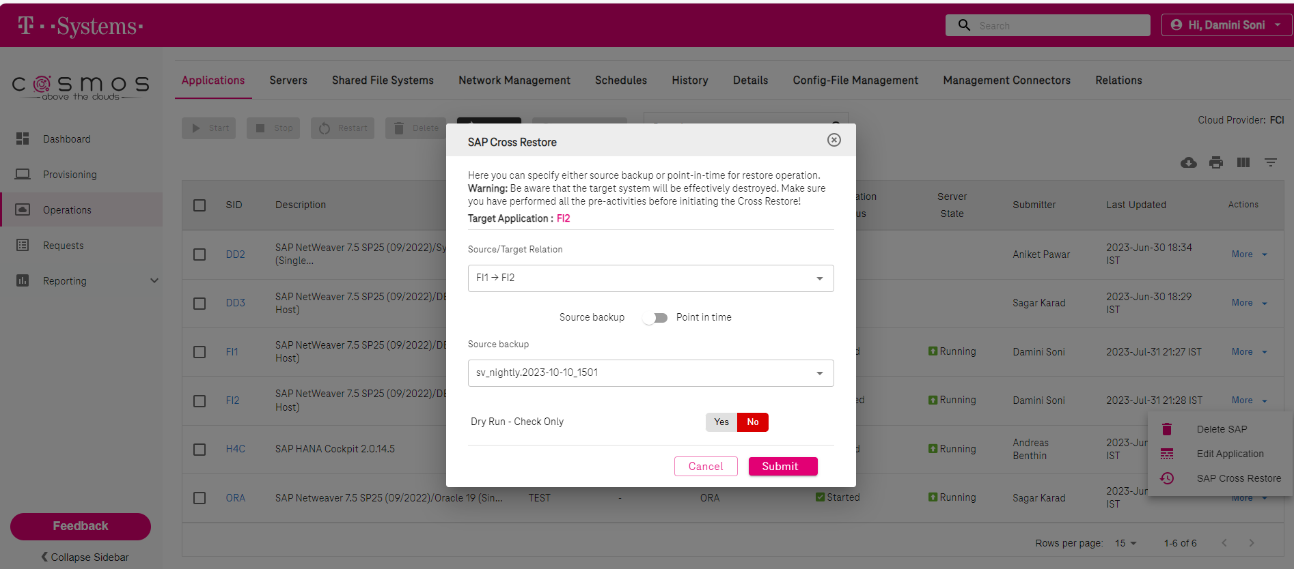



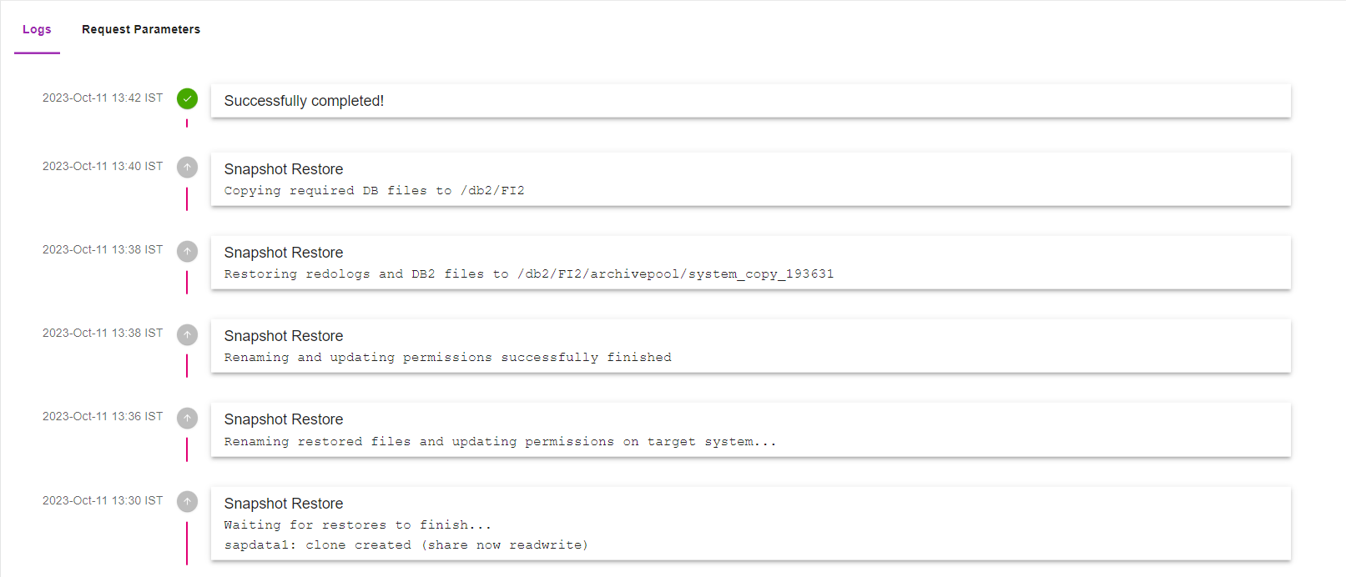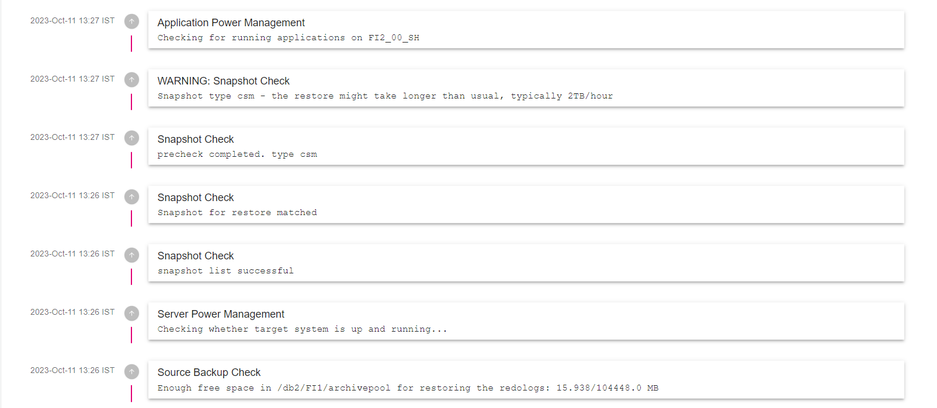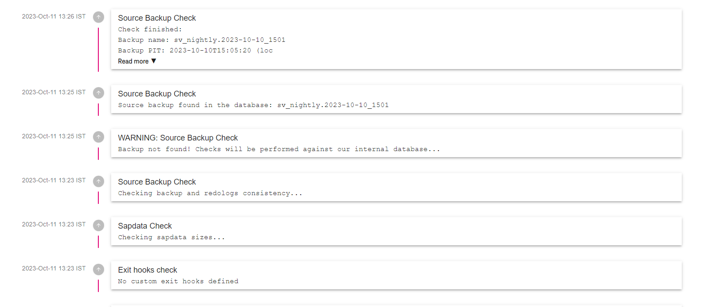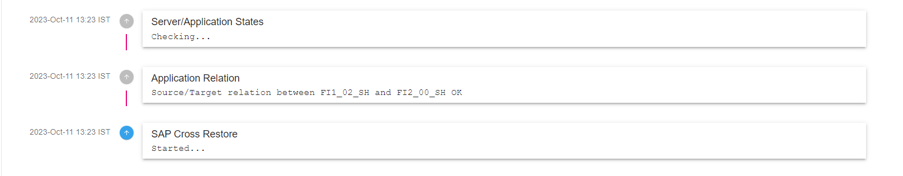

**fcishfi20001:/db2/FI2/archivepool/system_copy_193631 # ls -ltr**

total 44052

-rw-r--r-- 1 32002 sapsys 165114 Oct 10 14:36 xbrbackstatFI1.log

-rw-r--r-- 1 32002 sapsys 2088 Oct 10 15:00 xbrbackFI1.log

-rw-r--r-- 1 32002 sapsys 2726 Oct 10 15:01 DBM.cfg

-rw-r--r-- 1 32002 sapsys 44666880 Oct 10 15:01 FI1_db2_home.tar.Z

-rw-r--r-- 1 32002 sapsys 68243 Oct 10 15:04 gfcfesac.anf

drwxr-xr-x 3 32002 sapsys 4096 Oct 11 10:08 db2fi1

drwxr-xr-x 3 root root 4096 Oct 11 10:09 db2

**fcishfi20001:/db2/FI2/archivepool/system_copy_193631 # ls -ltr /db2/FI2/archivepool/system_copy_193631//db2fi1/FI1/NODE0000/LOGSTREAM0000/C0000001**

total 4912

-rw-r--r-- 1 32002 sapsys 4972544 Oct 10 15:01 S0001838.LOG

-rw-r--r-- 1 32002 sapsys 12288 Oct 10 15:01 S0001839.LOG

-rw-r--r-- 1 32002 sapsys 12288 Oct 10 15:01 S0001840.LOG

-rw-r--r-- 1 32002 sapsys 12288 Oct 10 15:03 S0001841.LOG

**fcishfi20001:/db2/FI2/archivepool/system_copy_193631 # ps -ef | grep db2sysc**

db2fi2 2118 2116 0 Aug31 ? 00:34:16 db2sysc 0

root 22435 22130 0 10:19 pts/0 00:00:00 grep --color=auto db2sysc

**fcishfi20001:/db2/FI2/archivepool/system_copy_193631 # su - db2fi2**

**fcishfi20001:db2fi2 54> ls -ltr**

total 6368

drwxr-xr-x 2 db2fi2 dbfi2adm 24 Jul 6 2021 public_html

drwxr-xr-x 2 db2fi2 dbfi2adm 6 Mar 15 2022 bin

drwxrwsr-t 24 db2fi2 dbfi2adm 4096 Jul 31 18:47 sqllib

-rw-r--r-- 1 db2fi2 dbfi2adm 501 Aug 1 08:36 relocate_fi1_fi2

-rw-r--r-- 1 db2fi2 dbfi2adm 3911574 Aug 3 17:35 script_FI2.sql

-rw-r--r-- 1 db2fi2 dbfi2adm 2597517 Aug 3 17:38 script_FI2.out

**fcishfi20001:db2fi2 55> db2 connect**

SQL1328N An implicit connection attempt failed. The database alias name or

database name "FI2" was not found in the local database directory.

SQLSTATE=42705

**fcishfi20001:db2fi2 56> db2inidb FI2 as standby relocate using relocate_fi1_fi2**

Relocating database...

Files and control structures were changed successfully.

Database was catalogued successfully.

DBT1000I The tool completed successfully.

Database relocation was successful.

DBT1000I The tool completed successfully.

**fcishfi20001:db2fi2 57> db2 get db cfg for fi2 | grep -i log**

Log retain for recovery status = NO

User exit for logging status = YES

Catalog cache size (4KB) (CATALOGCACHE_SZ) = 8000

Log buffer size (4KB) (LOGBUFSZ) = 1024

Active log space disk capacity (MB) (LOG_DISK_CAP) = 0

Log file size (4KB) (LOGFILSIZ) = 20000

Number of primary log files (LOGPRIMARY) = 60

Number of secondary log files (LOGSECOND) = 0

Changed path to log files (NEWLOGPATH) =

Path to log files = /db2/FI2/log_dir/NODE0000/LOGSTREAM0000/

Overflow log path (OVERFLOWLOGPATH) =

Mirror log path (MIRRORLOGPATH) =

First active log file = S0001839.LOG

Block log on disk full (BLK_LOG_DSK_FUL) = YES

Block non logged operations (BLOCKNONLOGGED) = NO

Percent max primary log space by transaction (MAX_LOG) = 0

Num. of active log files for 1 active UOW(NUM_LOG_SPAN) = 0

Percent log file reclaimed before soft chckpt (SOFTMAX) = 0

HADR log write synchronization mode (HADR_SYNCMODE) = NEARSYNC

HADR spool log data limit (4KB) (HADR_SPOOL_LIMIT) = AUTOMATIC(0)

HADR log replay delay (seconds) (HADR_REPLAY_DELAY) = 0

**First log archive method (LOGARCHMETH1) = DISK:/db2/FI1/log_archive/**

Archive compression for logarchmeth1 (LOGARCHCOMPR1) = OFF

Options for logarchmeth1 (LOGARCHOPT1) =

Second log archive method (LOGARCHMETH2) = OFF

Archive compression for logarchmeth2 (LOGARCHCOMPR2) = OFF

Options for logarchmeth2 (LOGARCHOPT2) =

Failover log archive path (FAILARCHPATH) =

Number of log archive retries on error (NUMARCHRETRY) = 5

Log archive retry Delay (secs) (ARCHRETRYDELAY) = 20

Log pages during index build (LOGINDEXBUILD) = OFF

Log DDL Statements (LOG_DDL_STMTS) = NO

Log Application Information (LOG_APPL_INFO) = NO

**fcishfi20001:db2fi2 58> db2 update db cfg for FI2 using LOGARCHMETH1 DISK:/db2/FI2/log_archive/**

DB20000I The UPDATE DATABASE CONFIGURATION command completed successfully.

**fcishfi20001:db2fi2 59> rm -rf /db2/FI2/log_dir/NODE0000/LOGSTREAM0000/\***

**fcishfi20001:db2fi2 60> ls -l /db2/FI2/log_dir/NODE0000/LOGSTREAM0000/**

total 0

**fcishfi20001:db2fi2 61> db2 update dbm cfg using INSTANCE_MEMORY 30**

DB20000I The UPDATE DATABASE MANAGER CONFIGURATION command completed

successfully.

**fcishfi20001:db2fi2 62> db2 update db cfg for FI2 using LOGPRIMARY 60**

DB20000I The UPDATE DATABASE CONFIGURATION command completed successfully.

**fcishfi20001:db2fi2 63> rm -rf /db2/FI2/log_archive/db2fi2/FI2/NODE0000/LOGSTREAM0000/\***

**fcishfi20001:db2fi2 64> db2stop; db2start**

10/11/2023 10:21:58 0 0 SQL1064N DB2STOP processing was successful.

SQL1064N DB2STOP processing was successful.

10/11/2023 10:21:59 0 0 SQL1063N DB2START processing was successful.

SQL1063N DB2START processing was successful.

**fcishfi20001:db2fi2 65> db2 rollforward db FI2 query status**

Rollforward Status

Input database alias = FI2

Number of members have returned status = 1

Member ID = 0

Rollforward status = DB pending

Next log file to be read = S0001839.LOG

Log files processed = S0000008.LOG - S0000069.LOG

Last committed transaction = 2023-10-10-13.01.23.000000 UTC

**fcishfi20001:db2fi2 66> db2 rollforward db FI2 to end of logs and complete overflow log path "(/db2/FI2/archivepool/system_copy_193631/db2fi1/FI1/NODE0000/LOGSTREAM0000/C0000001/)"**

Rollforward Status

Input database alias = FI2

Number of members have returned status = 1

Member ID = 0

Rollforward status = not pending

Next log file to be read =

Log files processed = S0001839.LOG - S0001840.LOG

Last committed transaction = 2023-10-10-13.03.43.000000 UTC

DB20000I The ROLLFORWARD command completed successfully.

**fcishfi20001:db2fi2 67> db2 connect**

Database Connection Information

Database server = DB2/LINUXX8664 11.5.8.0

SQL authorization ID = DB2FI2

Local database alias = FI2

### Recovered Changed:

**fcishfi20001:db2fi2 68> db2pd -db fi2 -tablespace | grep -i increment**

0x00007FC7A28C9900 1 DMS Large 16384 2 Yes 2 1 1 Def 1 0 511 Yes INCREMENTAL CHECKS

0x00007FC7A28D6CC0 2 DMS Large 16384 2 Yes 2 1 1 Def 1 0 511 Yes EXTRA_INCREMENT

**fcishfi20001:db2fi2 69> db2 list tables for all | grep -i increment**

INCREMENT INCREMENTAL T 2023-08-01-07.43.13.495105

**fcishfi20001:db2fi2 70> db2 load query table INCREMENTAL.INCREMENT**

Tablestate:

Normal

**fcishfi20001:db2fi2 71> ls -ltr /db2/FI2/sapdata1/**

total 4

-rwxr-xr-x 1 db2fi2 dbfi2adm 0 Aug 1 07:45 pmu.test

drwxr-xr-x 3 db2fi2 dbfi2adm 4096 Aug 3 11:46 db2fi2

## Point In Time Backup Restore:

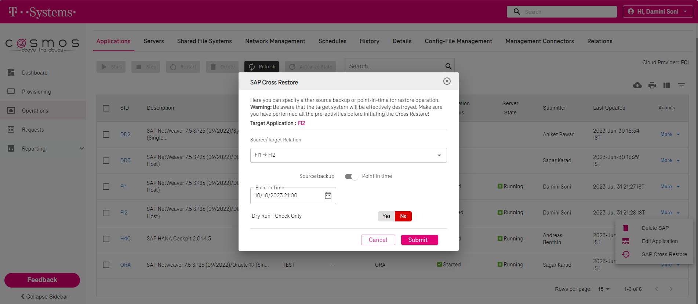

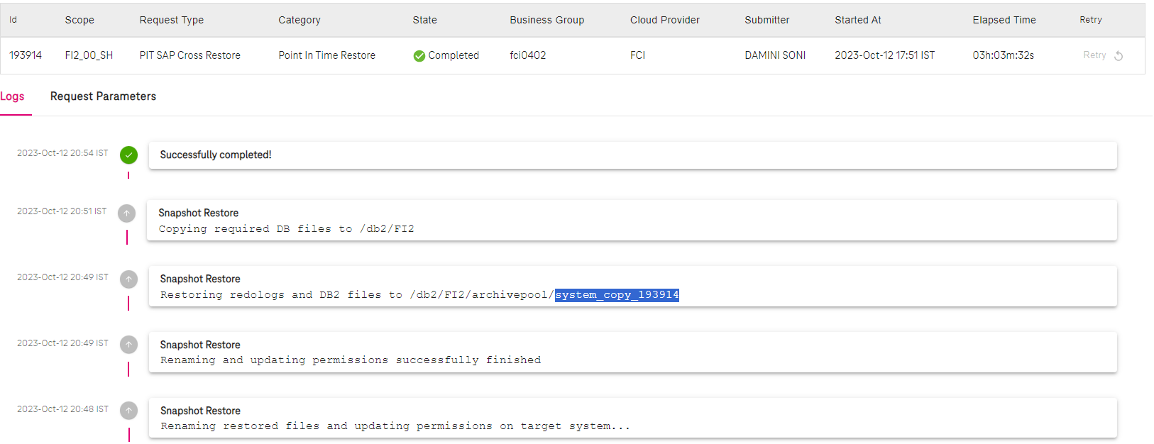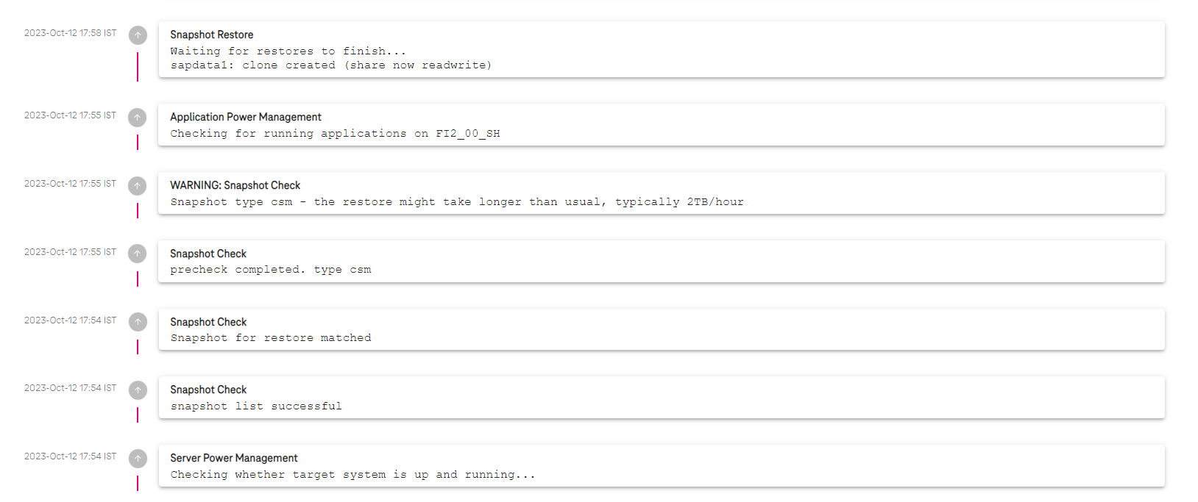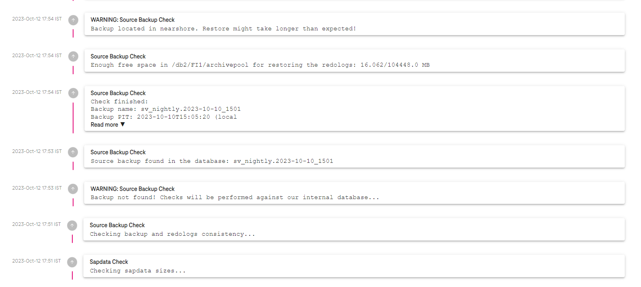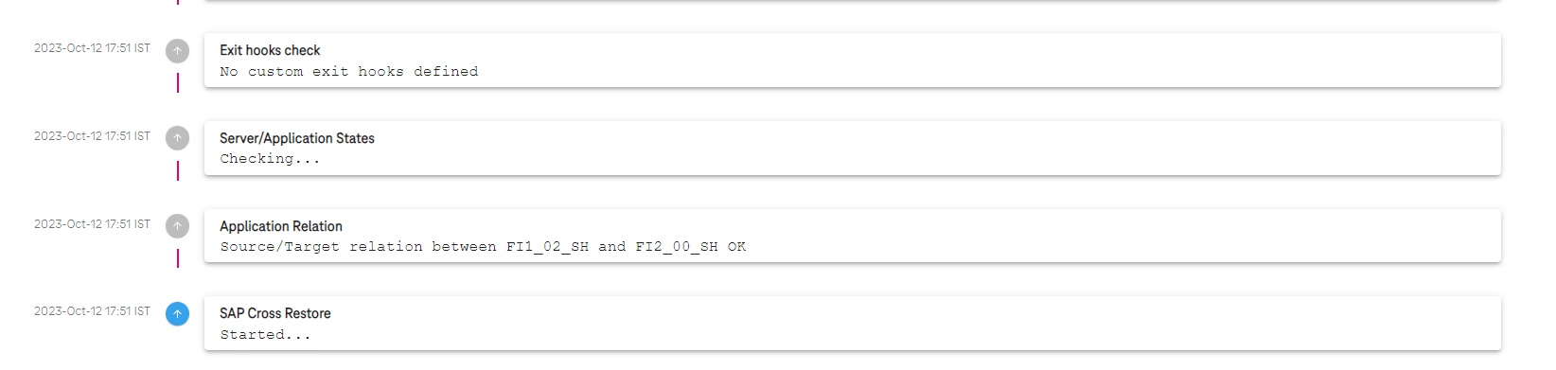

**fcishfi20001:~ # df -h**

Filesystem Size Used Avail Use% Mounted on

..

[2a00:0da9:0102:1004:0000:0000:0000:3000]:/vol/fcivssc0083000_fi2db_data001/c008_fi2db_data1/fi2db/vgadb_h_d/sapdata1 102G 19G 84G 18% /db2/FI2/sapdata1

**fcishfi20001:~ # ls -ltr /db2/FI2/archivepool/system_copy_193914**

total 44052

-rw-r--r-- 1 32002 sapsys 165114 Oct 10 14:36 xbrbackstatFI1.log

-rw-r--r-- 1 32002 sapsys 2088 Oct 10 15:00 xbrbackFI1.log

-rw-r--r-- 1 32002 sapsys 2726 Oct 10 15:01 DBM.cfg

-rw-r--r-- 1 32002 sapsys 44666880 Oct 10 15:01 FI1_db2_home.tar.Z

-rw-r--r-- 1 32002 sapsys 68243 Oct 10 15:04 gfcfesac.anf

drwxr-xr-x 3 32002 sapsys 4096 Oct 12 17:20 db2fi1

drwxr-xr-x 3 root root 4096 Oct 12 17:20 db2

**fcishfi20001:~ # ls -ltr /db2/FI2/archivepool/system_copy_193914/db2fi1/FI1/NODE0000/LOGSTREAM0000/C0000001/**

total 5052

-rw-r--r-- 1 32002 sapsys 4972544 Oct 10 15:01 S0001838.LOG

-rw-r--r-- 1 32002 sapsys 12288 Oct 10 15:01 S0001839.LOG

-rw-r--r-- 1 32002 sapsys 12288 Oct 10 15:01 S0001840.LOG

-rw-r--r-- 1 32002 sapsys 12288 Oct 10 15:03 S0001841.LOG

-rw-r--r-- 1 32002 sapsys 139264 Oct 10 16:05 S0001842.LOG

**fcishfi20001:~ # su - db2fi2**

**fcishfi20001:db2fi2 54> db2pd -**

Database Member 0 -- Active -- Up 0 days 16:33:44 -- Date 2023-10-13-06.45.59.856313

**fcishfi20001:db2fi2 54> ls -ltr**

total 6368

drwxr-xr-x 2 db2fi2 dbfi2adm 24 Jul 6 2021 public_html

drwxr-xr-x 2 db2fi2 dbfi2adm 6 Mar 15 2022 bin

drwxrwsr-t 24 db2fi2 dbfi2adm 4096 Jul 31 18:47 sqllib

-rw-r--r-- 1 db2fi2 dbfi2adm 501 Aug 1 08:36 relocate_fi1_fi2

-rw-r--r-- 1 db2fi2 dbfi2adm 3911574 Aug 3 17:35 script_FI2.sql

-rw-r--r-- 1 db2fi2 dbfi2adm 2597517 Aug 3 17:38 script_FI2.out

**fcishfi20001:db2fi2 55> db2 connect**

SQL1328N An implicit connection attempt failed. The database alias name or

database name "FI2" was not found in the local database directory.

SQLSTATE=42705

**fcishfi20001:db2fi2 56> db2inidb FI2 as standby relocate using relocate_fi1_fi2**

Relocating database...

Files and control structures were changed successfully.

Database was catalogued successfully.

DBT1000I The tool completed successfully.

Database relocation was successful.

DBT1000I The tool completed successfully.

**fcishfi20001:db2fi2 57> db2 get db cfg for fi2 | grep -i log**

Log retain for recovery status = NO

User exit for logging status = YES

Catalog cache size (4KB) (CATALOGCACHE_SZ) = 8000

Log buffer size (4KB) (LOGBUFSZ) = 1024

Active log space disk capacity (MB) (LOG_DISK_CAP) = 0

Log file size (4KB) (LOGFILSIZ) = 20000

Number of primary log files (LOGPRIMARY) = 60

Number of secondary log files (LOGSECOND) = 0

Changed path to log files (NEWLOGPATH) =

Path to log files = /db2/FI2/log_dir/NODE0000/LOGSTREAM0000/

Overflow log path (OVERFLOWLOGPATH) =

Mirror log path (MIRRORLOGPATH) =

First active log file = S0001839.LOG

Block log on disk full (BLK_LOG_DSK_FUL) = YES

Block non logged operations (BLOCKNONLOGGED) = NO

Percent max primary log space by transaction (MAX_LOG) = 0

Num. of active log files for 1 active UOW(NUM_LOG_SPAN) = 0

Percent log file reclaimed before soft chckpt (SOFTMAX) = 0

HADR log write synchronization mode (HADR_SYNCMODE) = NEARSYNC

HADR spool log data limit (4KB) (HADR_SPOOL_LIMIT) = AUTOMATIC(0)

HADR log replay delay (seconds) (HADR_REPLAY_DELAY) = 0

First log archive method (LOGARCHMETH1) = DISK:/db2/FI1/log_archive/

Archive compression for logarchmeth1 (LOGARCHCOMPR1) = OFF

Options for logarchmeth1 (LOGARCHOPT1) =

Second log archive method (LOGARCHMETH2) = OFF

Archive compression for logarchmeth2 (LOGARCHCOMPR2) = OFF

Options for logarchmeth2 (LOGARCHOPT2) =

Failover log archive path (FAILARCHPATH) =

Number of log archive retries on error (NUMARCHRETRY) = 5

Log archive retry Delay (secs) (ARCHRETRYDELAY) = 20

Log pages during index build (LOGINDEXBUILD) = OFF

Log DDL Statements (LOG_DDL_STMTS) = NO

Log Application Information (LOG_APPL_INFO) = NO

**fcishfi20001:db2fi2 58> db2 update db cfg for FI2 using LOGARCHMETH1 DISK:/db2/FI2/log_archive/**

DB20000I The UPDATE DATABASE CONFIGURATION command completed successfully.

**fcishfi20001:db2fi2 59> rm -rf /db2/FI2/log_dir/NODE0000/LOGSTREAM0000/\***

**fcishfi20001:db2fi2 60> ls -l /db2/FI2/log_dir/NODE0000/LOGSTREAM0000/**

total 0

**fcishfi20001:db2fi2 61> db2 update dbm cfg using INSTANCE_MEMORY 30**

DB20000I The UPDATE DATABASE MANAGER CONFIGURATION command completed

successfully.

**fcishfi20001:db2fi2 62> db2 update db cfg for FI2 using LOGPRIMARY 60**

DB20000I The UPDATE DATABASE CONFIGURATION command completed successfully.

**fcishfi20001:db2fi2 63> rm -rf /db2/FI2/log_archive/db2fi2/FI2/NODE0000/LOGSTREAM0000/\***

**fcishfi20001:db2fi2 64> db2stop; db2start**

10/13/2023 06:48:16 0 0 SQL1064N DB2STOP processing was successful.

SQL1064N DB2STOP processing was successful.

10/13/2023 06:48:18 0 0 SQL1063N DB2START processing was successful.

SQL1063N DB2START processing was successful.

**fcishfi20001:db2fi2 65> db2 rollforward db FI2 query status**

Rollforward Status

Input database alias = FI2

Number of members have returned status = 1

Member ID = 0

Rollforward status = DB pending

Next log file to be read = S0001839.LOG

Log files processed = S0000008.LOG - S0000069.LOG

Last committed transaction = 2023-10-10-13.01.23.000000 UTC

**fcishfi20001:db2fi2 66> db2 rollforward db FI2 to end of logs and complete overflow log path "(/db2/FI2/archivepool/system_copy_193914/db2fi1/FI1/NODE0000/LOGSTREAM0000/C0000001/)"**

Rollforward Status

Input database alias = FI2

Number of members have returned status = 1

Member ID = 0

Rollforward status = not pending

Next log file to be read =

Log files processed = S0001839.LOG - S0001841.LOG

Last committed transaction = 2023-10-10-14.04.34.000000 UTC

DB20000I The ROLLFORWARD command completed successfully.

**fcishfi20001:db2fi2 67> db2 connect**

Database Connection Information

Database server = DB2/LINUXX8664 11.5.8.0

SQL authorization ID = DB2FI2

Local database alias = FI2

### Recovered Changes

**fcishfi20001:db2fi2 68> db2pd -db fi2 -tablespace | grep -i increment**

0x00007F33F68C9900 1 DMS Large 16384 2 Yes 2 1 1 Def 1 0 511 Yes INCREMENTAL CHECKS

0x00007F33F68D6CC0 2 DMS Large 16384 2 Yes 2 1 1 Def 1 0 511 Yes EXTRA_INCREMENT

**fcishfi20001:db2fi2 69> db2 list tables for all | grep -i increment**

INCREMENT INCREMENTAL T 2023-08-01-07.43.13.495105

**fcishfi20001:db2fi2 70> db2 load query table INCREMENTAL.INCREMENT**

Tablestate:

Normal

**fcishfi20001:db2fi2 71> ls -ltr /db2/FI2/sapdata1/**

total 4

-rwxr-xr-x 1 db2fi2 dbfi2adm 0 Aug 1 07:45 pmu.test

drwxr-xr-x 3 db2fi2 dbfi2adm 4096 Aug 3 11:46 db2fi2

fcishfi20001:db2fi2 72>